Game scenario

The junk yard has been invaded by rats. In order to keep the paths walkable, the number of rats must be lowered or kept at a safe number since they are constantly multiplying. As the one in charge of the junk yard, the player must place traps and lure the rodents into them with various bait found among the garbage.

Game loop

How does it meet the brief?

* Single player
* Consider a genre or type of games that have a typical mechanic or set of mechanics defined as integral to them – >chosen genre: shooter game; mechanic: shooting

What is a shooter? = “taking action at a distance with the air of some kind of a mechanical device (…) built around to the player’s ability to control the device to achieve the desired effect. Usually but not always, the effect is destructive.” (Fundamentals of Shooter Game Design by Ernest Adams, published by New Riders, 2014)

* Substitute the mechanic – trapping (find items to place on the traps in order to catch rats)
* Emphasis on a single mechanic – trapping

Other details about the game:

* PVE (player vs environment)
* First person
* Nature of interaction:
  + What is the player trying to achieve? R: eliminating as many rats as possible
  + Why? R: if the rats exceed a certain number on the map, the game is over
* Nature of the target: destroyable, grants points to the player, does not deal damage to the pawn/avatar. Movement of the rats: move in single patterns (if possible, movement governed by guidance of complex artificial intelligence = AI)

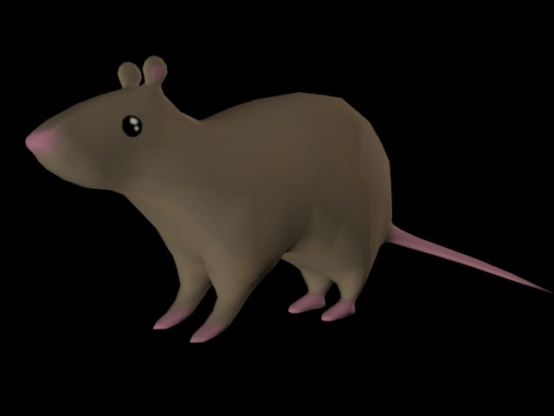

Art style:

* 3D
* Low poly
* Hard edges
* Block colours
* 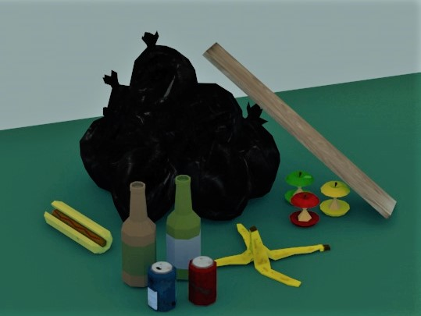Lack of detail

Level design:

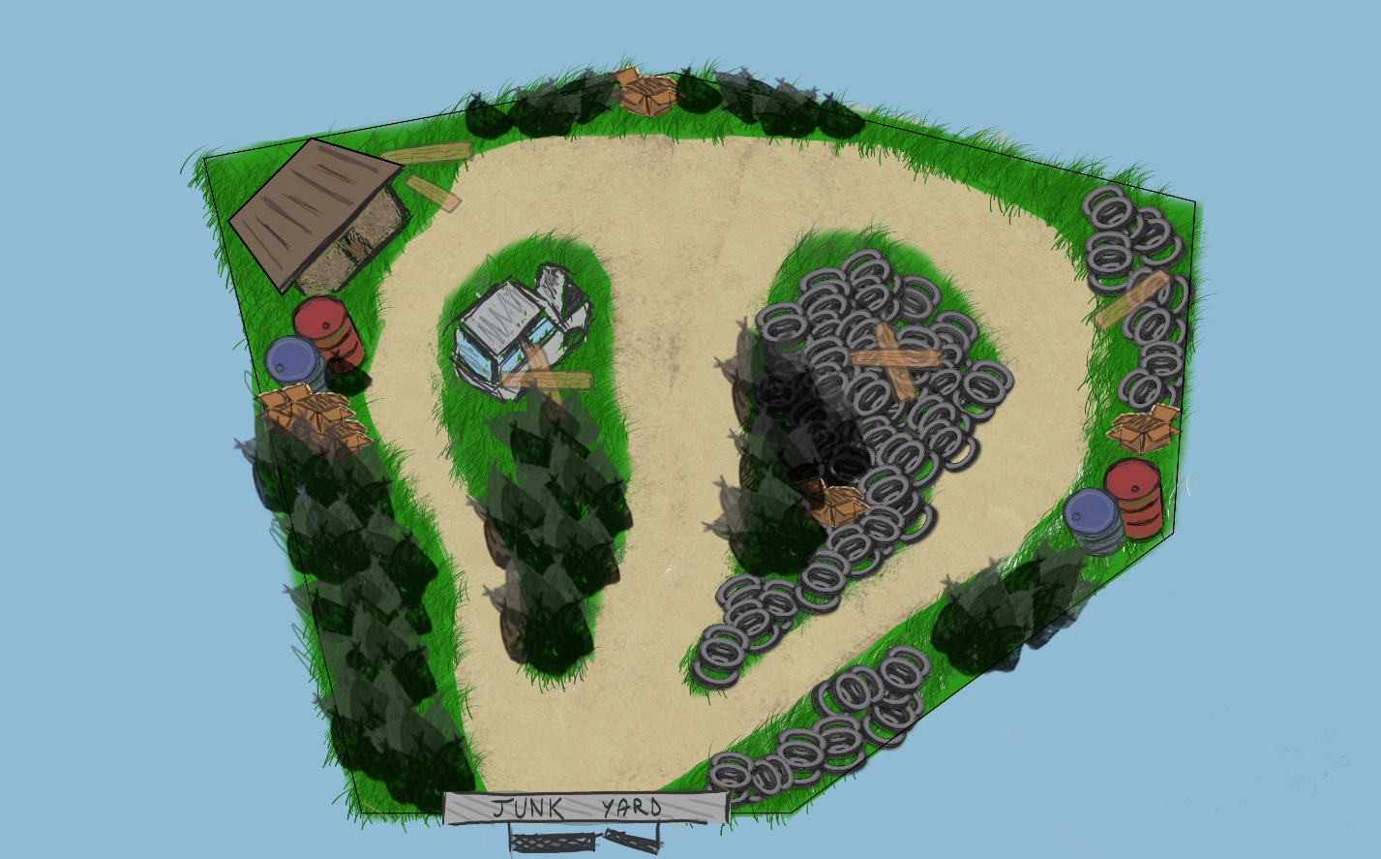

Making use of positive space to put emphasis on the ide of ‘dwelling’; obstructed visibility caused by the elements that separate the lanes

The shed= place where you restock on traps

Gate: start position of the player

Aesthetics:

Creating dramatic tension: inevitability (the nr of rats increases over time and the game will end once the invasion is beyond control= too many rats will lead to the game being over) + uncertainty (unknown outcome: how long can you keep the rat invasion under control? Possibly beat the highest score?)

Types of fun:

Easy fun

* Exploration (explore to find bait)
* Creativity (combine the traps with different objects around the junk yard to find which one attracts the rats)
* Wonder (objects have different proprieties- some attract more than one rat)

Hard fun

* Fiero (beating the high score)

Serious fun:

* Rhythm (place trap- find bait- catch rats)

Player skills tested:

Mental (observational skills- finding bait)

Possible game names:

1. Rat invasion
2. Boring day at work